Exercise Sheet - 12/01

Exercise session 1
- Create the following scenario in MATLAB
  - Create a matrix named map as in the figure below
  - Attribute the obstacle values
- Create a function to print the map
- Insert the robot:
  - Create another matrix [1,2] to store the robot position
  - Adapt the function of item 2 to print “R” where the robot is
- Implement the function “move(direction, robot_pos)” to move the robot

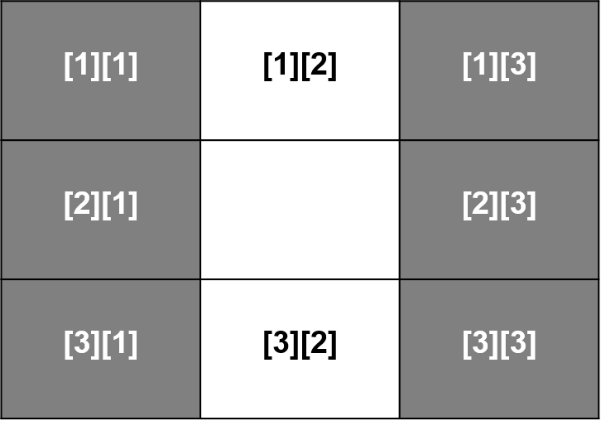
  - Test your function with values hardcoded defined (meaning declaring the values in your code)

Exercise session 2
- Implement the verifications in the functions implemented in Session 1:
  - Verify if the cell is free before moving
  - Verify whether the next move goes out of the map (edges)
  - Implement a function that given two numbers n and m, create a mesh map of size n*m with all the cells
- Make sure your print_map function handles the new map
  - Adapt your code so you can take the next direction from the keyboard (users insert next direction)

Exercise session 3
- Test your code in the following mesh maze (7x7):
  - Don’t forget to test the condition for out of map (successfully exited)
- Modify your code to search for the exit autonomously (checking all the directions)
- Cells to start
  - [6][2]
  - [4][4]
  - [2][6]
[6][2]
[4][4]
[6][2]

Handout:
Work in pairs to handout tomorrow a best solution for the robot to automatically scape the maze

